1. 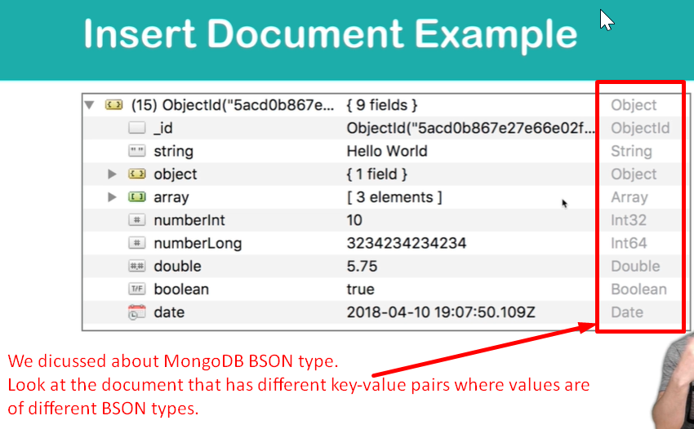
2. **Agenda**: Let’s create similar document in this lesson and look how MongoDB handles different MongoDB BSON types.
3. 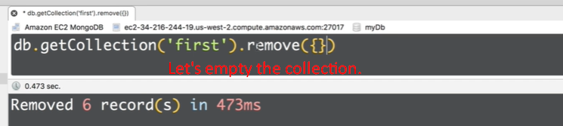
4. 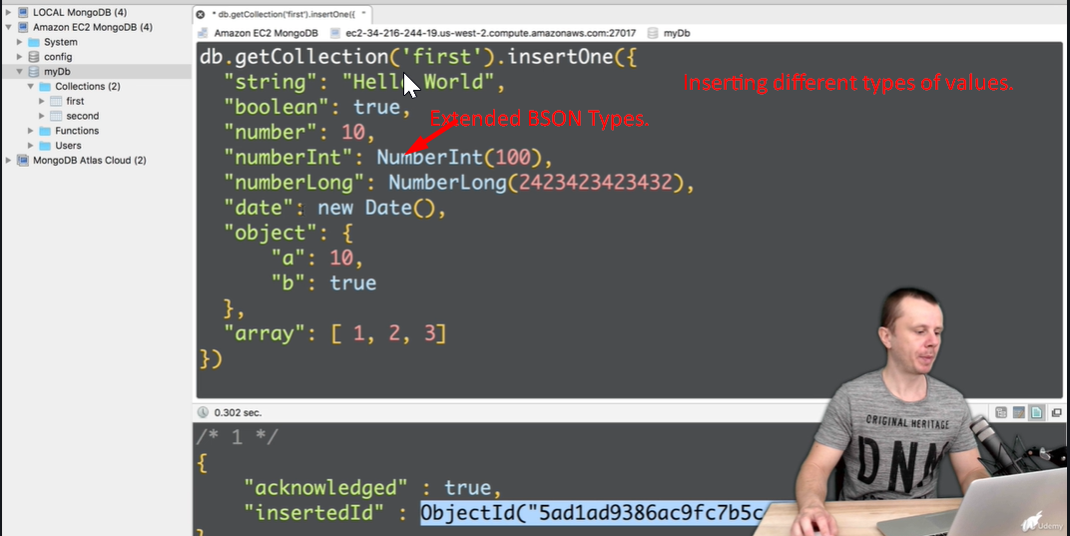
5. 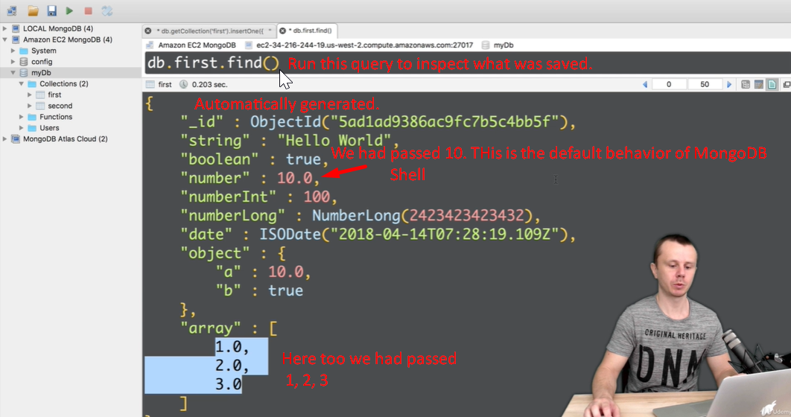
6. 